# CS 340 README Project Two

## About the Project/Project Title

The animal rescue group, Grazioso Salvare searches for suitable dogs for its work to adopt from animal shelters, with different types of dogs being required

## Motivation

Each different type of rescue work (Water, Mountain, and Disaster) requires dogs of different breeds and sexes and ages. The project accesses the animal shelter’s database, generating a table of animals in the shelter, and then three data filter can be applied, narrowing down the database to the animals suited for each time of work, including

## Getting Started

You’ll need MONGO Database installed, as well as a IDE and runtime environment for Python called Juypter Notebooks and a Python library called PYMONGO. You’ll also need a database called AAC with a collection called animals, although this can be changed to any database and collection with some simple changes to the animalshelter.py file.

## Installation

Unzip the project.zip into an appropriate directory.

## Usage

Run Juypter Notebook, navigate to the appropriate directory, and load the ProjectTwoJeremyReaban.ipynb, then run it.

Once it runs, click on the URL generated by the output window, which will launch the default web browser and open a dashboard. Wait a moment for the initial pie chart to load, as it must deal with thousands of animals.

### Once loaded, press the appropriate button on the left to filter results by Water, Mountain, or Disaster or Reset it back to the original list (which again will take a moment to update the pie chart).

### Screenshots

Initial View of Dash

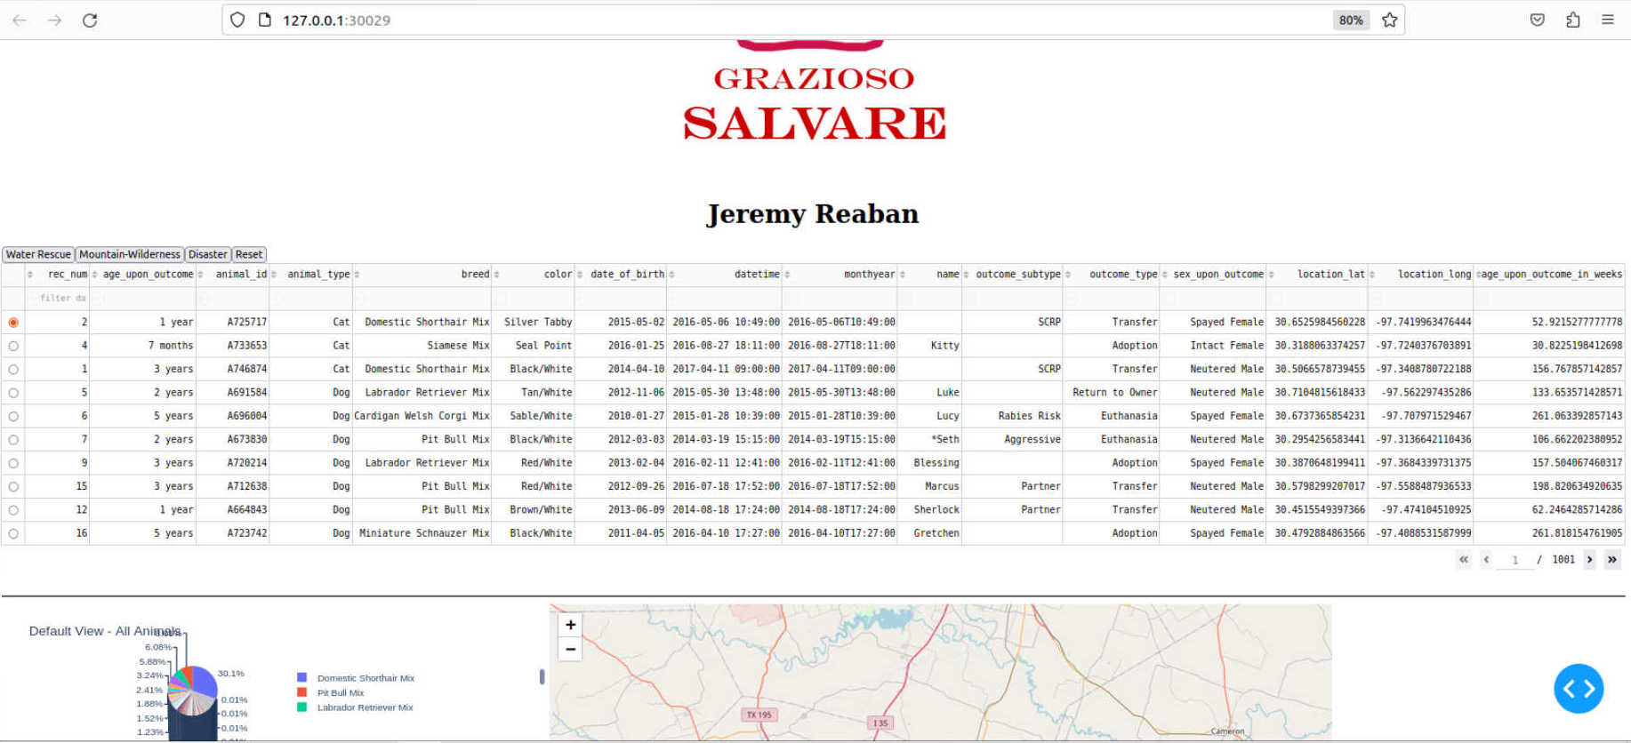

Picking Water (Note only Labrador Retrievers were among the suitable dogs at the shelter)

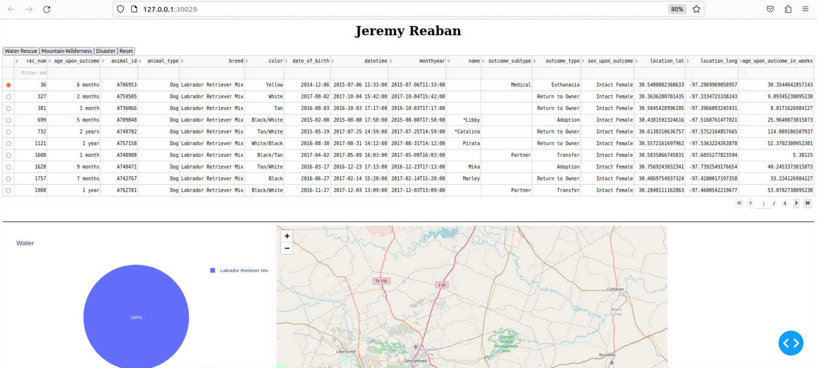

Picking Mountain

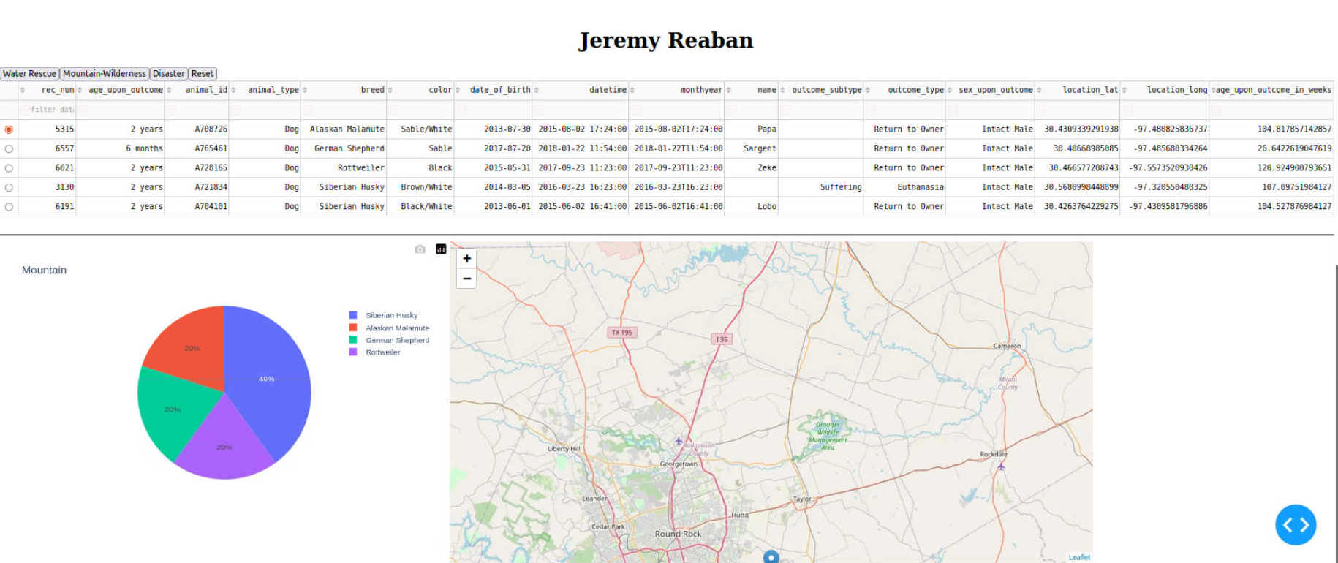

Picking Disaster

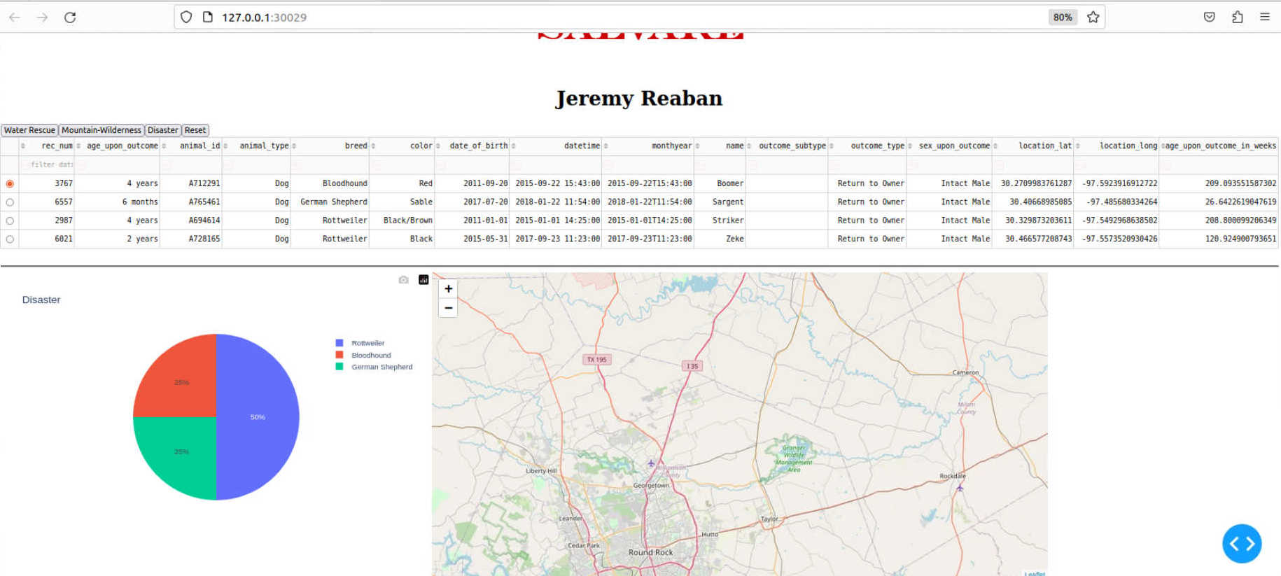

And lastly, the Reset View

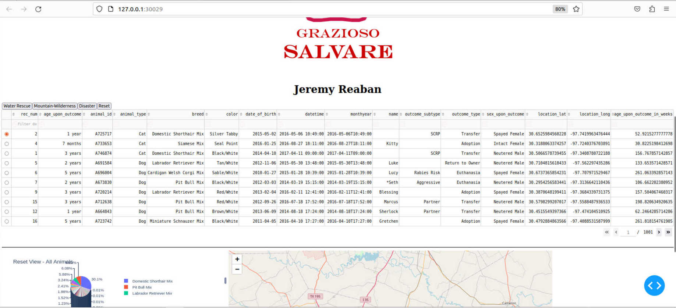

## Updates

Initial Release

## Roadmap/Features

Possible other rescue types

Modify search terms to animals that almost meet requirements (such as specific Newfoundland mixes for water rescue)

## Contact

Your name: Jeremy Reaban